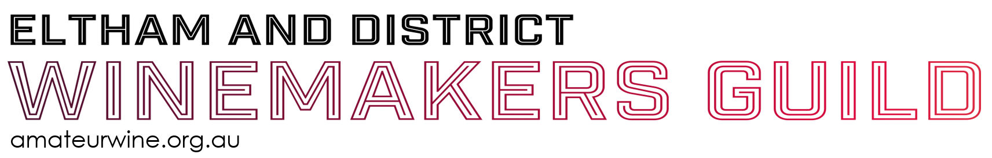
55th ELTHAM WINE SHOW

EARLY BIRD ENTRY FORM 2024

Entries Close
20th October 203

IMPORTANT DATES!
17th November 2024 | Wine Show Public Tasting, Awards Presentation..
Special Amateur Award | Jo Ilian Trophy: Country Wine - Liqueur
Rules | Published on the website: amateurwine.org.au

EARLY BIRD DOOR ENTRY FORM 2024

Surname: |  |  | First Name:
Address: |  |  |  |  |  | Post Code:
Telephone: |  |  | Mobile:
Email:
 | Public Entry Tickets @ $15 each, includes tasting glass |  |  | No. |  |  | $
 | Results books at $10 each |  |  | No. |  |  | $
 | Note: Cost of Wine Show entry is $20 on the public day |  |  | Total |  |  | $

Direct Deposit payment (preferred)
I have paid by Electronic Funds Transfer using the reference: ……………………………………………..
EFT Payments: Eltham & District Winemakers Guild Inc. BSB 032-591 Account No 449147 (Westpac Bank)
Credit Card payment
I wish to pay by credit card. Please send me an invoice to my email address
Please email this form to cheers@amateurwine.org.au

Privacy Note: Any email address supplied will only be used for Eltham Guild matters and not provided to third parties

