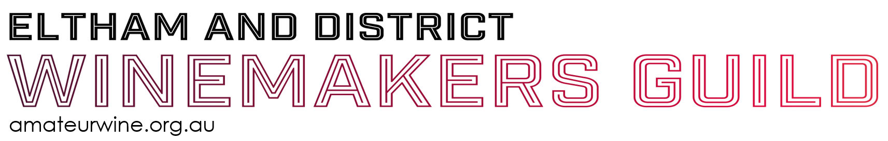
54th ELTHAM WINE SHOW
Early Bird Tickets Close
5pm 16th November 2023

EARLY BIRD TICKETS 2023

Entries Close
20th October 2023

IMPORTANT DATES!
19th November 2023 | Wine Show Public Open Day, Awards Presentation
Special Amateur Award 2023 | Jo Ilian Trophy: Pinot Noir

EARLY BIRD TICKET FORM 2023

Surname: |  | First Name:
Address:
 |  | Post Code:
Telephone: |  | Mobile:
Email:
Public Entry Tickets @ $15 each (includes tasting glass)  Note: Cost of Wine Show Entry is $20 on the Public Open Day |  |  | No. |  |  | $
Results books at $10 each |  |  | No. |  |  | $
 |  |  |  |  | TOTAL | $

Direct Deposit payment (preferred)
I have paid by Electronic Funds Transfer using the reference: ………..…………………………………………………
EFT Payments: Eltham & District Winemakers Guild Inc. BSB 032-591 Account No. 449147 (Westpac Bank)

Credit Card payment
I wish to pay by credit card. Please send an invoice to my email address
Please email this form to cheers@amateurwine.org.au

Privacy Note: Any email address supplied will only be used for Eltham Guild matters and not provided to third parties

